Selectable Damper Mode Function - S550 SVT Specific - CGEA 1.3

Functional Description
The Selectable Damper Mode Function allows a driver to cycle through a number of preset damper modes, each consisting of a particular suspension calibration.

The ECP provides the IPC with debounced Damper button press information via CAN, which communicates whether the momentary toggle switch is pressed or not pressed; this information is then used by the IPC to initiate a new damper mode request and display a corresponding pop-up screen. Each damper request is comprised of a separate command sent to the VDM module using the SuspDrvMde_D_Rq request signal:.

The first press of the damper button shall request that the damper pop-up be displayed, illustrating to the driver the current and available modes graphically. Subsequent presses of the damper button shall result in a new mode request, after a certain time delay, as long as the damper pop-up is active. Upon a new mode request, the cluster shall verify that the VDM module has entered the newly requested mode within a given amount of time by validating its respective status signal: SuspDrvMde_D_Stat.

This function is currently only intended for use in S550 SVT instrument clusters that are paired with a dedicated Damper momentary toggle switch located on the Front Controls Interface Modules (FCIM), also known as the Electronic Control Panel (ECP) module.

For 2018 S550 MCA program this function is being expanded from use only on SVT instrument clusters to all IPC. This function is only intended for use in S550 instrument clusters that are paired with a dedicated Damper momentary toggle switch located on the Front Controls Interface Modules (FCIM), also known as the Electronic Control Panel (ECP) module.

For 2018 S550 MCA program the “Magnaride” feature is being added and for certain malfunctions there will be speed limiting to 80mph. For the Magnaride feature an additional warning is being added to inform the operator vehicle speed is being limited to 80mph (130km/h). This is reflected in v2.0 of this STSS.

Interfaces

Interface Context Diagram (I/O Block Diagram)
Figure 1: Selectable Damper Mode Function Context Diagram
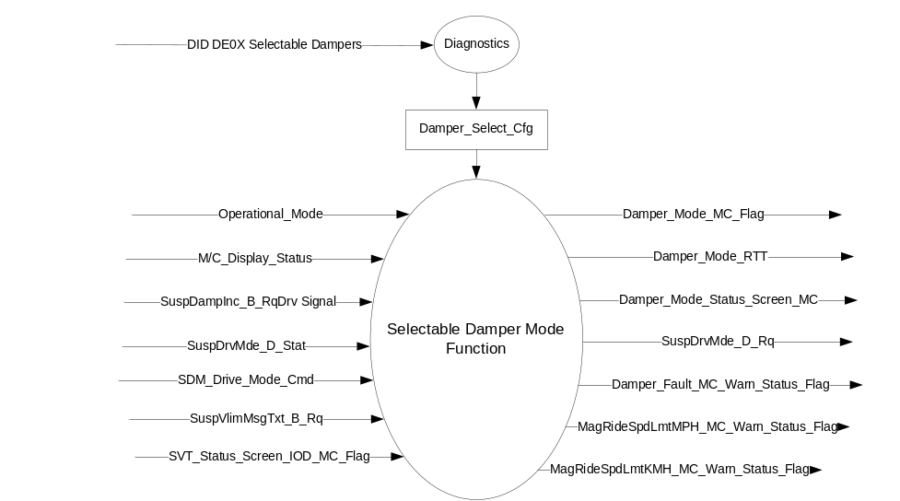

Inputs

- INTERNAL:
- Operational_Mode
- M/C_Display_Status
- SVT_Status_Screen_IOD_MC_Flag (from Status Screen Information – S550 SVT Only - CGEA1.3 STSS)
- Damper_Select_Cfg - Internally stored configuration bit
- SDM_Drive_Mode_Cmd – Please refer to the Selectable Drive Mode Function – S550 SVT Specific – CGEA1.3 STSS for more information.

- MUX messages on the CAN bus:

- SuspDrvMde_D_Stat Signal
Signal Name | Size  (bits) | Detail | Units | Res. | Offset | State  Encoded | Min | Max
SuspDrvMde_D_Stat | 3 |  | SED | 1 | 0 |  | 0 (0x0) | 7 (0x7)
 |  | Normal |  |  |  | 0x0
 |  | Sport |  |  |  | 0x1
 |  | Snow_Wet |  |  |  | 0x2
 |  | Track |  |  |  | 0x3
 |  | Drag |  |  |  | 0x4
 |  | NotUsed1 |  |  |  | 0x5
 |  | NotUsed2 |  |  |  | 0x6
 |  | Faulty |  |  |  | 0x7

- SuspDampInc_B_RqDrv Signal
Signal Name | Size  (bits) | Detail | Units | Res. | Offset | State  Encoded | Min | Max
SuspDampInc_B_RqDrv | 1 |  | SED | 1 | 0 |  | 0 (0x0) | 1 (0x1)
 |  | Not pressed |  |  |  | 0x0
 |  | Pressed |  |  |  | 0x1

- SuspVlimMsgTxt_B_Rq Signal
Signal Name | Size  (bits) | Detail | Units | Res. | Offset | State  Encoded | Min | Max
SuspVlimMsgTxt_B_Rq | 1 |  | SED | 1 | 0 |  | 0 (0x0) | 1 l(0x1)
 |  | No |  |  |  | 0x0
 |  | Yes |  |  |  | 0x1

Outputs
- Damper_Mode_Status_Screen_MC
- Damper_Mode_MC_Flag
- Damper_Mode_RTT
- Damper_Fault_MC_Warn_Status_Flag
- MagRideSpdLmtMPH_MC_Warn_Status_Flag
- MagRideSpdLmtKMH_MC_Warn_Status_Flag

- MUX messages on the CAN bus:

- VDMDrvMde_D_Rq Signal
Signal Name | Size  (bits) | Detail | Units | Res. | Offset | State  Encoded | Min | Max
SuspDrvMde_D_Rq | 3 |  | SED | 1 | 0 |  | 0 (0x0) | 7 (0x7)
 |  | Normal |  |  |  | 0x0
 |  | Sport |  |  |  | 0x1
 |  | Snow_Wet |  |  |  | 0x2
 |  | Track |  |  |  | 0x3
 |  | Drag |  |  |  | 0x4
 |  | Not Used1 |  |  |  | 0x5
 |  | Not Used2 |  |  |  | 0x6
 |  | Faulty |  |  |  | 0x7

Function/Performance

Operational Modes

Mode | Differentiating Vehicle Conditions
Sleep Mode | Selectable Damper Mode Function Disabled
Limited Mode | Selectable Damper Mode Function Disabled
Normal Mode | Selectable Damper Mode Function Enabled / Disabled
Crank Mode | Selectable Damper Mode Function Enabled / Disabled

Voltage Levels

Refer to the Cluster Features table located in the Operational Modes and Voltage Range Strategies Section in this SPSS.

Human-Machine Interface

Visual
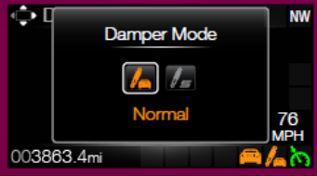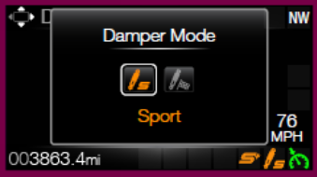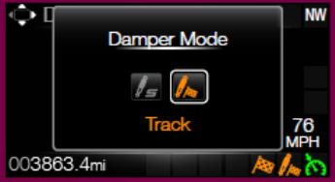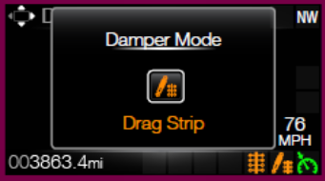

Graphics are for illustrative purposes only; refer to program specific graphics library.
.

Indicator Graphics / Display Format


For actual symbol pixel definition, see program specific HMI requirements.

Indicator Color Coordinates

Refer to program specific HMI requirements for styling direction.

Indicator Characteristics

Pixel display in Message Center Display – Damper_Mode_RTT.

Audio

None

Switch Control Logic

The SCCM module transmits an event periodic CAN signal (SuspDampInc_B_RqDrv) to inform the IPC if the Damper button is pressed or not pressed. The VDM handles all switch debouncing and fault conditions related to the damper momentary toggle switch without relaying this information to the cluster. A button press is defined as a transition from Not pressed to Pressed. There is no press and hold for the Damper button – a press and hold shall constitute a single button press.

System Accuracy

Within a 100msec of receiving a message that results in a change of state the cluster will update the display to the proper status.

Operation: Performance and Functional

Subsystem Algorithm Flowcharts / State Diagrams

Figure 2: Selectable Dampers Configuration Flowchart

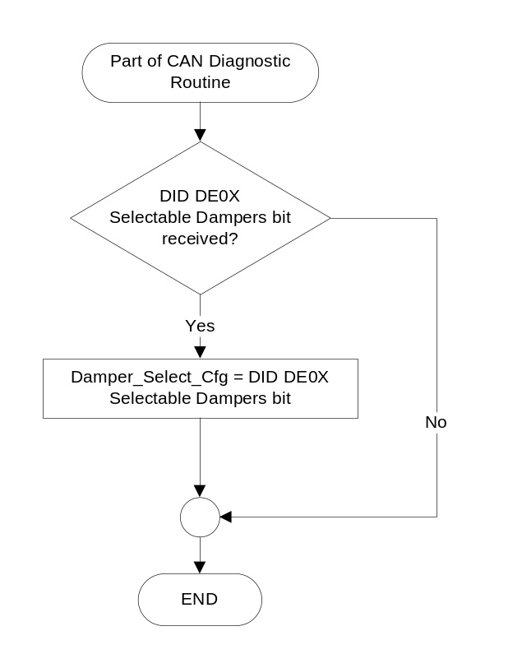
Figure 3: Selectable Damper Mode Control Function Flowchart

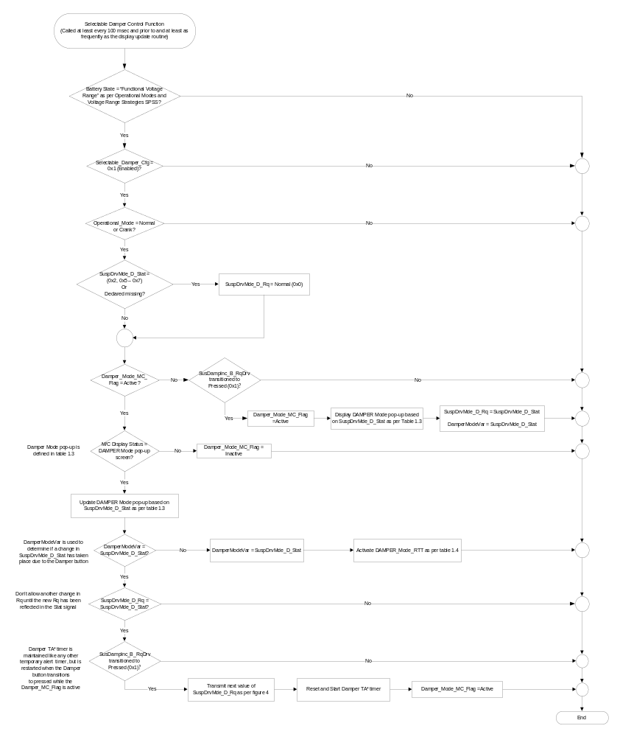

- MC Warning Message ID#, Valid Damper_Mode States and Sample Graphics Based on SuspDrvMde_D_Stat and Drive Mode Settings
Operational_  Mode | Selectable_  Damper_Cfg | Damper_MC_Flag | SDM_Drive_Mode_Cmd | SuspDrvMde_D_Stat | MC Warning Message ID# | Damper_Mode Valid States and Pop-up Sample Graphics
Normal or Crank | Enabled (0x1) | Active (0x1) | Normal | Normal (0x0) | W3341 | Normal (0x0)
 |  |  |  | Sport (0x1) | W3341 | Sport (0x1)
Normal or Crank | Enabled (0x1) | Active (0x1) | Sport | Normal (0x0) | W3341 | Sport (0x1)
 |  |  |  | Sport (0x1) | W3341 | Road Course (0x2)
Normal or Crank | Enabled (0x1) | Active (0x1) | Weather | Normal (0x0) | W3347 | Normal (0x0)
Normal or Crank | Enabled (0x1) | Active (0x1) | Road Course | Sport (0x1) | W3342 | Sport (0x1)
 |  |  |  | Track (0x3) | W3342 | Road Course (0x2)
Normal or Crank | Enabled (0x1) | Active (0x1) | Drag Strip | Drag (0x4) | W3343 | Drag (0x3)
Normal or Crank | Enabled (0x1) | Active (0x1) | X | Snow-Wet (0x2), Unused (0x5, 0x6), or Declared Missing | W3344 | Dampers Not Available
Normal or Crank | Enabled (0x1) | X | X | Faulty(0x7) | W1026 | Driver Select  Suspension Malfunction  Service Required
All other cases |  |  |  |  | Inactive | No graphic shown

Figure 4: Damper Mode State Diagram for SuspDrvMde_D_Rq
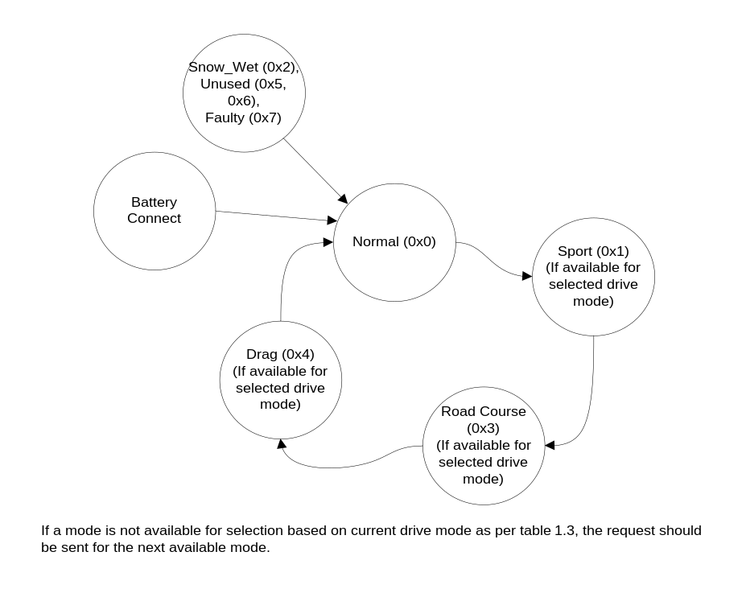
Figure 4: Damper RTT Activation Process Flowchart
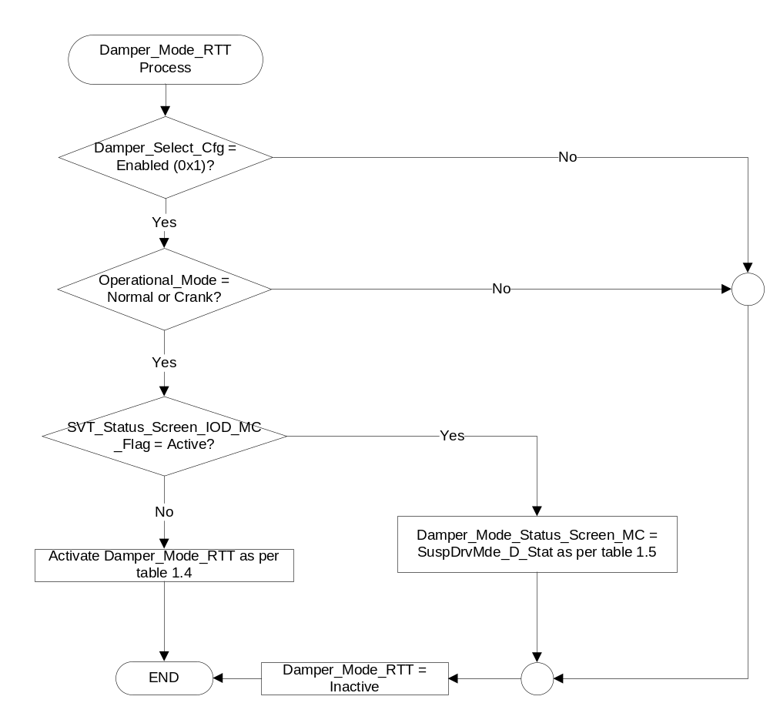

- Damper_Mode_RTT Based on SuspDrvMde_D_Stat
Operational_  Mode | Damper_Select_Cfg | SVT_Status_Screen_IOD_MC_Flag | SuspDrvMde_D_Stat | Damper_Mode_RTT
Normal or Crank | Enabled (0x1) | Inactive | Normal (0x0)
Normal or Crank | Enabled (0x1) | Inactive | Sport (0x1)
Normal or Crank | Enabled (0x1) | Inactive | Track (0x3)
Normal or Crank | Enabled (0x1) | Inactive | Drag (0x4)
Normal or Crank | Enabled (0x1) | Inactive | Snow_Wet (0x2),  Faulty (0x7) or  Declared Missing | Flash “Normal” RTT @4* Hz for 2 seconds and then solid active
All other cases |  |  |  | Inactive

Note: Any flash rate between 3 Hz and 4 Hz is acceptable as long as the flash rate is consistent.

- Damper_Mode_Status_Screen_MC Based on SuspDrvMde_D_Stat
Operational_  Mode | Damper_Select_Cfg | SVT_Status_Screen_IOD_MC_Flag | SuspDrvMde_D_Stat | Damper_Mode_  Status_Screen_MC
Normal or Crank | Enabled (0x1) | Active | Normal (0x0) | Normal
Normal or Crank | Enabled (0x1) | Active | Sport (0x1) | Sport
Normal or Crank | Enabled (0x1) | Active | Track (0x3) | Track
Normal or Crank | Enabled (0x1) | Active | Drag (0x4) | Drag Strip
Normal or Crank | Enabled (0x1) | Active | Snow_Wet (0x2),  or  Declared Missing | Normal
Normal or Crank | Enabled (0x1) | Active | Faulty (0x7) | Service
All other cases |  |  |  | Inactive
Note: Graphics shown above are for example purposes only.

- State Matrix for Damper_Fault_MC_Warn_Status
Operational_  Mode | Damper_Select_Cfg | SuspDrvMde_D_Stat | Damper_Mode_MC_Warn_Status_Flag
Normal or Crank | Enabled (0x1) | Faulty (0x7) | Active
Normal or Crank | Enabled (0x1) | Declared Missing | Inactive
All other cases |  |  | Inactive

- State Matrix for Suspension Fault Speed Limited Warnings
Operational_Mode | Damper  _Select_Cfg | Display_Units_MC⁽¹⁾ | SuspVlimMsgTxt_B_Rq  Signal | MagRideSpdLmtMPH  _MC_Warn_Status_Flag | MagRideSpdLmtKMH  _MC_Warn_Status_Flag
Normal or Crank | Enabled | English (0x0 l 0x1) | Yes (0x1) | Active | Inactive
Normal or Crank | Enabled | Metric (0x2 l 0x3) | Yes (0x1) | Inactive | Active
Normal or Crank | Enabled | X | Declared Missing | Inactive | Inactive
All Other Cases |  |  |  | Inactive
- See Display Unit Selection Control Function section for definition and function or Display_Units_MC

- State Matrix for Damper_Fault_MC_Warn_Status
Damper_Mode_MC  _Warn_Status_Flag | MagRideSpdLmtMPH  _MC_Warn_Status_Flag | MagRideSpdLmtKMH  _MC_Warn_Status_Flag | MC Message ID
Inactive | Inacitve | Inactive | None
Active | x | x | W1026
x | Active | x | W3560
x | x | Active | W3561

Operation Description (supports algorithm flowcharts / state diagrams)

- The first press of the dedicated Damper button shall request that the Damper mode pop-up be displayed with showing the current damper mode.

- Subsequent presses of the DAMPER button while the damper mode pop-up is active shall reset the TA_Timer, and request the next Damper mode via the SuspDrvMde_D_Rq CAN signal if conditions are true.

- If the damper mode pop-up is being actively displayed, then Damper_MC_Flag should be set to Active (0x1). If the damper mdoepop-up is interrupted for any reason, then the Damper_MC_Flag should be reset to Inactive (0x0). This prevents the damper feel pop-up from cycling with other pop-ups.

- Each press of the Damper button shall reset and restart the TA_timer for the Damper HMI pop-up if the Damper HMI is already active.

- The availability of damper modes is dependent on the Drive modes. Only a subset of damper modes is available for selection based on the currently selected Drive mode. Rest of the damper modes shall not be available for selection. The HMI graphics for unavailable damper modes shall either be grayed out or not displayed at all based on program/HMI direction.

- The IPC is responsible for requesting damper modes, but it is the VDM module’s responsibility to make the appropriate decisions to determine if the request can be fulfilled and respond positively or negatively via its status signal (SuspDrvMde_D_Stat).

- There is no interaction between the 5-way steering wheel switches and the Selectable Damper mode feature. Damper modes are controlled directly via an external switch located on the steering wheel. The SCCM is responsible for sending debounced pressed/not pressed information to the cluster via CAN.

- The Damper_Mode_RTT shall only be active while the SVT Status Screen is not actively displayed.

Function Safety Classification (EMC)

Class B

Memory Storage
Parameter Name | Description | Value at  Battery Connect | Value at  Module Wake-up
SuspDrvMde_D_Stat Signal | Input CAN signal indicating the current Damper mode. | Normal (0x0) | Normal (0x0)
SuspDampInc_B_RqDrv Signal | Input CAN signal indicating if the Damper button is Pressed or Not pressed. | Not pressed (0x0) | Not pressed (0x0)
SuspVlimMsgTxt_B_Rq | Input CAN signal to control display of the suspension fault speed limited warnings. | No (0x0) | No (0x0)
SuspDrvMde_D_Rq Signal | Output CAN signal to request a damper mode. | Normal (0x0) | Normal (0x0)
SVT_Status_Screen_IOD_MC_Flag | Internal input from “Status Screen Information Display – CGEA1.3” STSS
Damper_Select_Cfg | Internal flag to indicate if Damper modes can be selected in the vehicle. Disabled means the feature is not present in the vehicle. | Use Stored Value | Use Stored Value
SDM_Drive_Mode_Cmd | Provides current drive mode selected by the user, which determines the available damper modes for selection. | Refer to the Selectable Drive Mode – S550 SVT Specific – CGEA1.3 STSS for more information.
Damper_MC_Flag | Internal flag used to control the state of the selectable damper mode pop-up. This variable can reset the warning prior to the TA_Timer expiring. | Inactive (0x0) | Inactive (0x0)
Damper_Mode_RTT | Internal variable used to control the state of the Damper mode RTT. | Inactive (0x0) | Inactive (0x0)
Damper_Mode_Status_  Screen_MC | Output used to display Damper mode in the SVT Status screen | Inactive | Inactive
DamperModeVar | Internal parameter used to determine if Damper mode request matches the status received from VDM. | Normal (0x0) | Normal (0x0)
Damper_Fault_MC_Warn_Status  _Flag | Warning status flag for damper fault | Inactive | Inactive
MagRideSpdLmtMPH_MC_Warn  _Status_Flag | Warning status flag for English units suspension speed limited warning. | Inactive | Inactive
MagRideSpdLmtKMH_MC_Warn  _Status_Flag | Warning status flag for English units suspension speed limited warning. | Inactive | Inactive
M/C_Display_Status | State indicator to identify which text is currently being displayed on Message Center display. See * | See * below | See * below
Operational_Mode | 4 state indicator for cluster operational mode. | Limited | Limited, Normal or Crank

* Refer to Message Center X Display_Y Button Interface Section, where X and Y are appropriate values in this document.

Reconfigurable Telltale

Yes. See Section 1.3.3.2 Indicator Graphics / Display Format, and Table 1.13.

Prove Out

Not applicable.

Message Center Msg

Yes, as per table 1.3 and program specific HMI graphics library.

Error Handling

Missing Message Strategy

The signals will be declared missing as per the Diagnostics section of this STSS.
DTCs states and history will be determined as per the Diagnostics section of this STSS.
If Damper_Select_Cfg = Disabled (0x0), the cluster shall never log a missing message DTC due to this feature.

Diagnostics

Self Test

None.

Engineering Test Mode

Reference section “Dealer / Engineering Test Mode (ETM)”

Part II Performance

Supported Diagnostic DIDs (Service $22)
None

DID $DE0X:
Block  Num | Block Description | Byte(s) | Bits | State: Description | "0" | "1" | Default
PACKETED BLOCKS
$0X | Option Content (B&A) | * | * | Selectable Dampers | Disabled | Enabled | Disabled
 | *Byte and bit location to be identified in Part II Specification for this cluster

Supported Diagnostic Trouble Codes (DTCs)

DTCs shall be logged as per the diagnostics section of this SPSS.*

DTC | Description
C12200 | Lost Communication With VDM module
C21200 | Lost Communication with Steering Column Control Module (SCCM)
* If the missing signal has a related update bit, _UB, signal, then the “Invalid Data” DTC is to be logged. Otherwise, the “Lost Communication” DTC is logged.

Reference Specifications

IS-0001 WARNINGS/INDICATORS/DISPLAYS PROVEOUT
IS-0052 OPERATING VOLTAGES - FUNCTIONAL/PERFORMANCE
IS-0069 FUNCTIONAL IMPORTANCE CLASS
IS-0324 WINDSHIELD & OTHER REFLECTIONS
IS-0327 WARNING INDICATOR EVALUATION
IS-0379 NORTH AMERICAN WARNINGS AND INDICATORS STRATEGY

IL-0019 GENERAL ILLUMINATION DIMMING
IL-0021 CRAFTSMANSHIP - DISPLAYS
IL-0022 GENERAL ILLUMINTATION COLOR
IL-0023 CLARITY/LEGIBILITY/READABILITY
IL-0025 INTERIOR ILLUMINATION INTENSITY
IL-0027 VISUAL CONTRAST
IL-0043 OPERATIONAL ENVIRONMENT FUNCTIONALITY
IL-0045 COLOR
IL-0048 ILLUMINATION ACCEPTABILITY

03-0661 PLACEMENT: CONTROL AND DISPLAY LOCATIONS
03-0662 PLACEMENT: LOGICAL GROUPING FUNCTION AND USAGE
03-0664 PLACEMENT: DOWN VISION TO COMPONENTS WITH HIGH VISUAL DEMAND
03-0665 PLACEMENT: EXPECTED LOCATIONS OF CONTROLS AND DISPLAYS VDS
03-0670 INTERIOR VISIBILITY
03-0671 INTERIOR VISIBILITY: REFLECTIONS FROM COMPONENTS & SURFACES
03-0672 INTERIOR VISIBILITY: REFLECTIONS IN DISPLAYS
03-0673 INTERIOR VISIBILITY: VISUAL OBSCURATIONS
03-0674 INTERIOR VISIBILITY: ILLUMINATION CONTROLS / DISPLAYS
03-0675 INTERIOR VISIBILITY: VEILING GLARE
03-0677 INTERIOR VISIBILITY: SUNLIGHT WASHOUT
03-0681 IDENTIFICATION: CHARACTER AND SYMBOL SIZE
03-0682 IDENTIFICATION: LEGIBILITY
03-0685 IDENTIFICATION: SYMBOLS, ABBREV FOR CONTROL
03-0721 LOGIC OF OPERATION: OPERATIONAL STEREOTYPES
03-0722 LOGIC OF OPERATION: INTERPRETATION
03-0723 LOGIC OF OPERATION: USE OF SYSTEMS WITH VISUAL DISPLAYS

Revision History
STSS Module Revision History
Revision Level | Name | Change Description | Date
1.0 | V. Patel | Initial release for 2015.75 S550 SVT variant.  Feature owners: Mike Makled, Michael Leese (S550 SVT Electrical team) | 11/4/2013
1.1 | V. Patel | Main purpose of this update is to add a Suspension warning message for Fault conditions. (DI CC approval 8/21/2014) – All updates are in Red.  - Section 1.2.1, Figure 1: Added an output warning message status flag.  - Section 1.2.3: Added output status flag variable.  - Section 1.3.5.1  - Table 1.3: Added a row to activate the warning message status flag for Faulty (0x7) state of the input signal.  - Table 1.5: Added a row to show “Fault” under the Dampers icon in the Status screen for Faulty (0x7) state of the input signal  - Table 1.6: Created state matrix table for the new warning.  - Section 1.3.5.4: Added warning message status flag and init values in the memory storage table. | 9/4/2014
V1.2 | M. Makled | Updated Table 1.3 to change the Damper Selection options for Sport SDM | 3/20/2015
1.3 | A. Venuturupalli  S. Watkins | Table 1.4 – Clarified that the “Normal” Damper Mode RTT should flash when SuspDrvMde_D_Stat is 0x2, 0x7 or missing.  Per Denso Q&A #39 S550 SVT MY16 | 5/5/2015
2.0 | J. Blatchford | This update adds suspension fault speed limited warnings at the request of VDM group. Feature owner and contact for this change was Mohamed, Ahmed (A.) amoha124@ford.com from VDM group. Also note this function is being expanded to non-SVT S550 vehicles. Except for Figure 1 changes highlighted in yellow.  - Title: Crossed out reference to SVT.  - 1.1 Added paragraph and updated second paragraph and crossed out reference to SVT.  - Table 1.2: Added table.  - 1.2.3: Added outputs.  - Table 1.8: Added table.  - Table 1.9: Added Table.  - 1.3.5.4: Added input signals, added status flags. | 2/10/2016
2.1 | J. Blatchford | Corrected copy error. Sequence # copied from GML in update 2.0 instead of W#s. Minor update to prevent Q&A change.  - Table 1.9: Corrected W# to W3560 & W3561. | 5/11/2016
2.2 | V. Patel | Ford Performance, to match the implementation on the Base program, would like the “Faulty” state displayed as “Service” on the status screen.  Direction received from: Todd Scaminaci, Ford Performance.  Section 1.3.5.1, table 1.6: Replaced “Faulty” with “Service” in the last row that displays status for the Faulty bit on the SuspDrvMde_D_Stat signal. | 10/31/2017

